# Timpiste sa Choláiste Samhraidh

These notes were written by my teacher, not me.

## Pictiúr 1

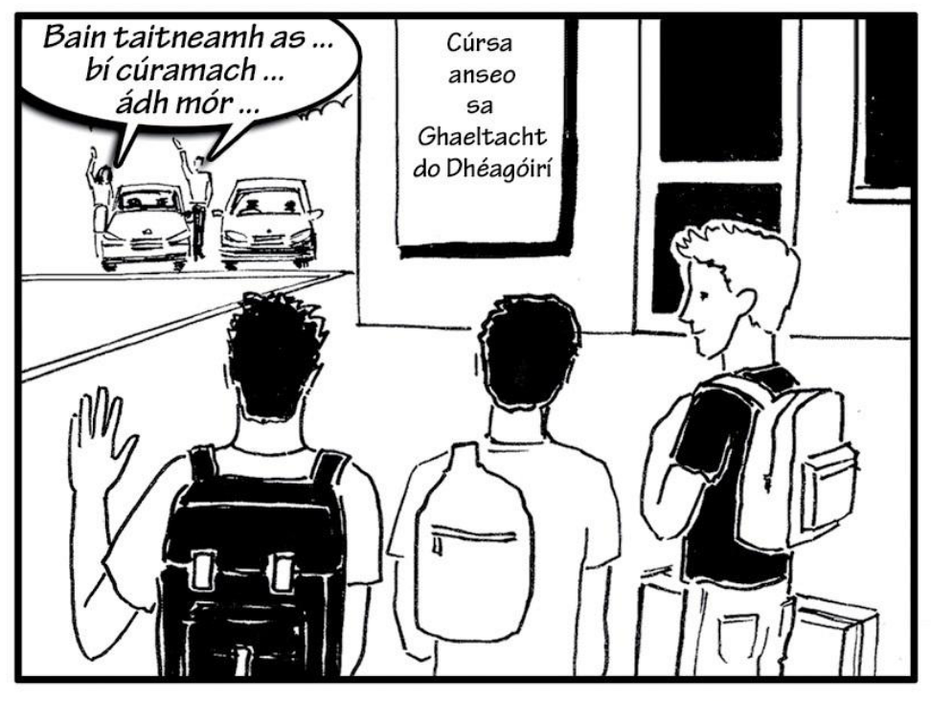

Thug na tuismitheoirí síob dá gcuid páistí go dtí an Ghaeltacht. D’fhág siad slán acu agus d’imigh siad abhaile ina ngluaisteáin. Bhí na déagóirí chun cúrsa a dhéanamh sa choláiste samhraidh i gCiarraí. Triúr buachaillí a bhí sa ghrúpa agus bhí málaí droma orthu.

**Translation:** The parents gave their children a lift to the Gaeltacht. They said goodbye to them and they went home in their car. The boys were doing a course in the summer college in Kerry. There was three boys in the group, and they had backpacks.

## Pictiúr 2

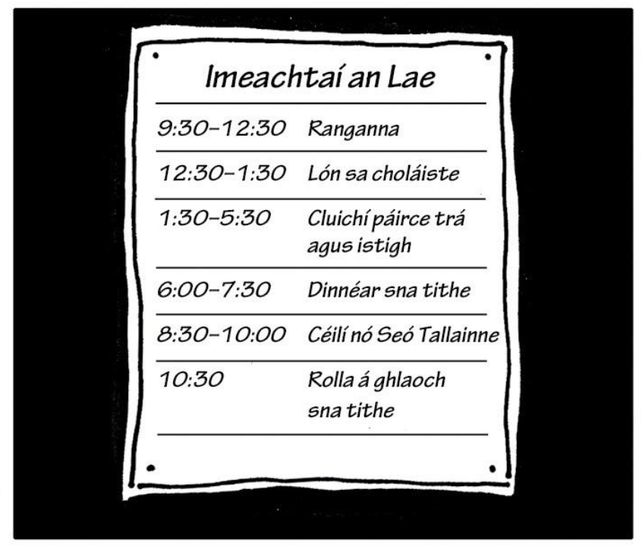

Bhí a lán imeachtaí ar siúl gach lá sa Ghaeltacht. Ar maidin bhí ranganna ar siúl agus bhí uair a’ chloig saor ag na daltaí le haghaidh lóin sa choláiste. Sa tráthnóna bhí imeachtaí spóirt ar siúl, cluichí amuigh agus istigh, turas go dtí an trá agus ansin an dinnéar ag a sé a chlog. San oíche bhí céilí nó seó tallainne ar siúl agus ansin ghlaoigh na múinteoirí an rolla sna tithe ag leathuair tar éis a deich.

**Translation:** There were a lot of activities on every day in the Gaeltacht. In the morning, there were classes, and the students had an hour free for lunch in the college. In the afternoon their was sports activities. Outdoor and indoor games. Dinner is at 6 o’clock. At nighttime, there was a ceilí or a talent show, and then the teachers called the roll in the houses at half ten.

## Pictiúr 3

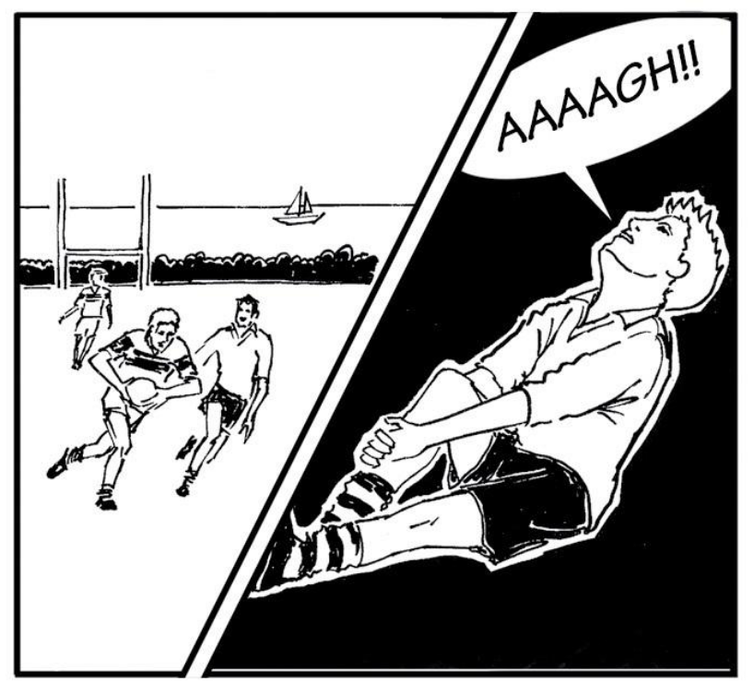

Sa chéad phictiúr bhí buachaillí ag imirt cluiche peile. Bhí an aimsir go hálainn. Bhí an pháirc peile suite cois na farraige agus bhí bád seoil amuigh ar an bhfarraige. Go tobann lig buachaill amháin scread as agus thit sé ar an talamh. Bhí greim aige ar a chos agus bhí sé soiléir go raibh sé i bpian go mór. Bhí an chuma ar an scéal gur ghortaigh sé a chos agus é ag imirt peile.

**Translation**: In the first picture, the boys are playing football. The weather was lovely. The pitch was located beside the sea, and there was a sailboat out on the sea. Suddenly, a boy screamed and fell to the floor. He was holding his leg. It appeared that he hurt his leg while playing football.

## Pictiúr 4

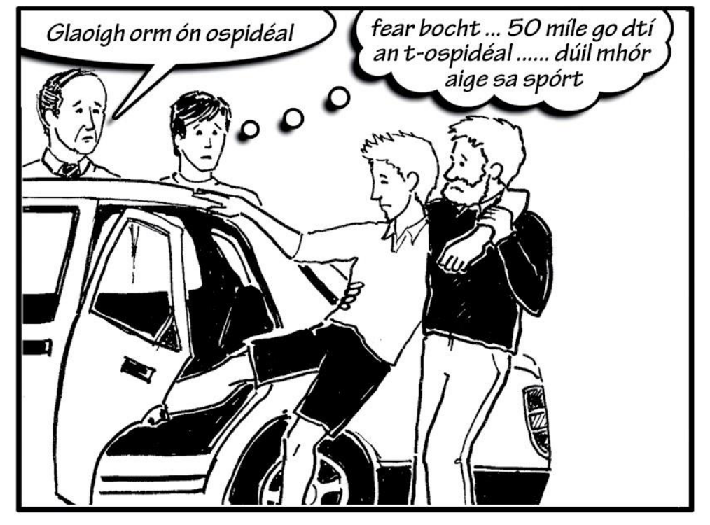

Bhí duine de na múinteoirí ag cabhrú leis an mbuachaill gortaithe dul isteach sa charr. Bhí caoga míle le dul go dtí an t-ospidéal. Dúirt an t-ardmháistir leis an múinteoir glaoch a chur air ón ospidéal. Bhí trua ag cara an bhuachalla ghortaithe dó mar go raibh turas fada le déanamh aige agus mar go raibh dúil mhór aige sa spórt.

One of the teachers was helping the injured boy to enter the car. There were fifty thousand going to the hospital. The high master told the teacher to call him from the hospital. The boyfriend’s pity was sorry to hurt him because he had a long journey and he had a great deal of sport.

**Translation**: One of the teachers was helping the injured boy get into the car. There was 50 miles to go to the hospital. The headmaster told the teacher to call him from the hospital. The boy’s friend had pitty on hum because he had a long journey and he hada lot of sport.

## Pictiúr 5

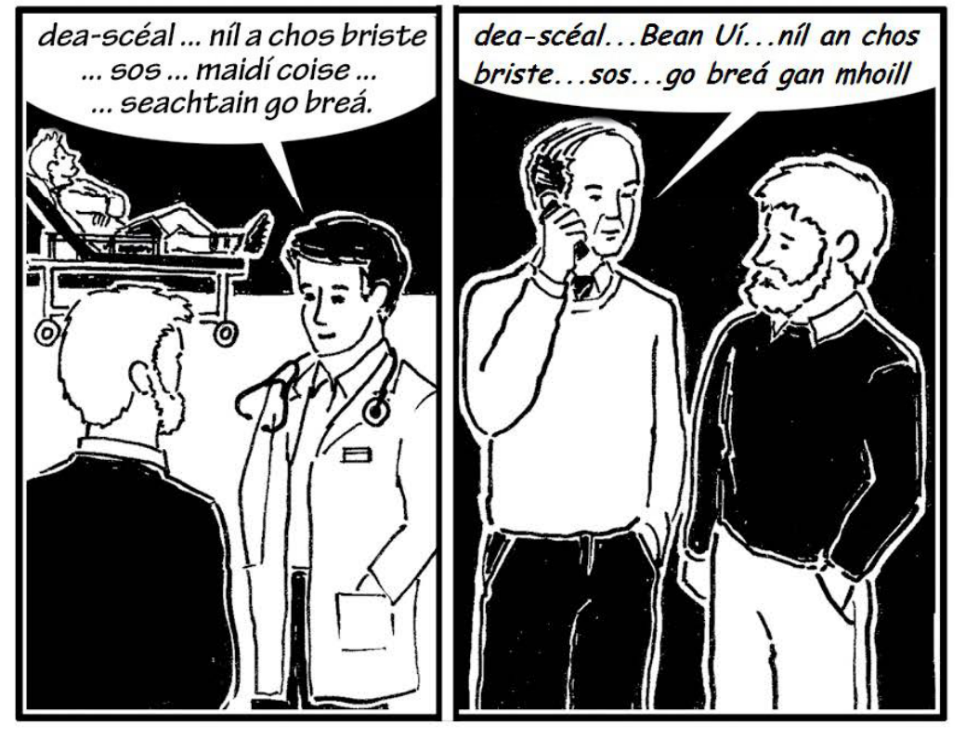

Bhí an buachaill gortaithe ina luí ar shínteán sa chéad phictiúr. Bhí an dochtúir ag labhairt leis an múinteoir. Dúirt sé leis go raibh dea-scéal aige dó. Ní raibh cos an bhuachalla briste. Bheadh air sos a ghlacadh agus bheadh sé ar mhaidí croise ach bheadh sé go breá faoi cheann seachtaine. Sa dara pictiúr chuir an príomhoide glaoch gutháin ar mháthair an bhuachalla. Dúirt sé léi nach raibh a chos briste, go mbeadh air sos a ghlacadh ach go mbeadh sé go breá gan mhoill.

**Translation**: The injured boy was lying on s tretcher in the first picture. The doctor was talking to the teacher. He told him he had good news. The boys leg was not broken. He would have to take a break, and he would be on crutches, but he would be grand in a week. In the second picture, the principle rang the boys mother. He said that her leg wasn’t broken, that he’d have to take a break. But that he would be grand before long.

## Pictiúr 6

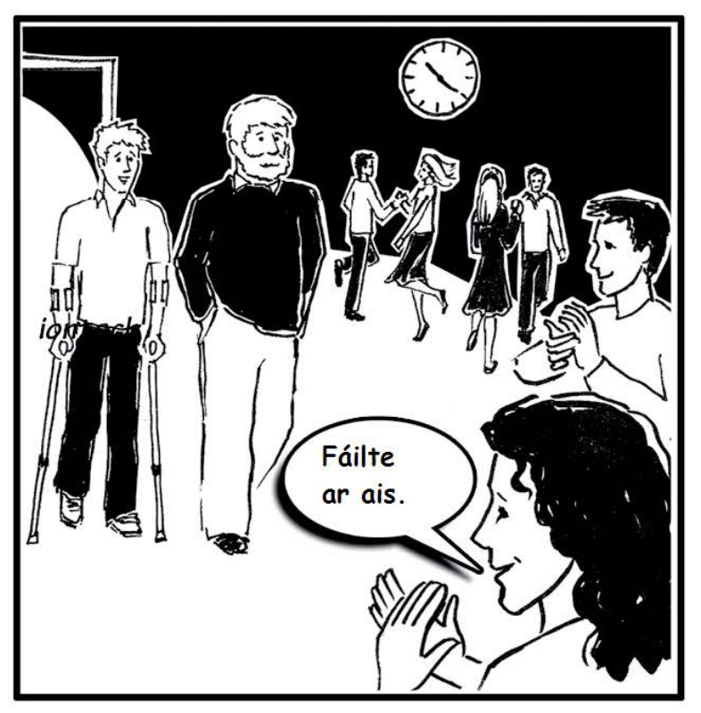

D’fhill an buachaill agus an múinteoir ar an gcoláiste ag a fiche tar éis a deich an oíche sin. Bhí an céilí faoi lánseoil sa halla agus bhí daltaí ag rince. Chuir cairde an bhuachalla na múrtha fáilte roimhe agus thug said bualadh bos mór dó. Bhí an céilí beagnach thart agus bheadh sé ag dul thar n-ais go dtí an teach lóistín lena chairde sara i bhfad.

**Translation**: The boy and the teachcer returned to the college at twenty past ten that night. There was a ceilí in full swing in the hall and the students were dancing. The boys friends gave him a great welcome, and they gave him a big round of a applause. The ceilí was nearly over, and he would be going back to the house with his friends before long.